Session 2025-2026

Vision: Dream of where you want. | Mission: Means to achieve Vision

Program Educational Objectives of the program (PEO): (broad statements that describe the professional and career accomplishments)
PEO1 | Preparation | P: Preparation | Pep-CL abbreviation  pronounce as Pep-si-lL easy to recall
PEO2 | Core Competence | E: Environment (Learning Environment) | Pep-CL abbreviation  pronounce as Pep-si-lL easy to recall
PEO3 | Breadth | P: Professionalism | Pep-CL abbreviation  pronounce as Pep-si-lL easy to recall
PEO4 | Professionalism | C: Core Competence | Pep-CL abbreviation  pronounce as Pep-si-lL easy to recall
PEO5 | Learning Environment | L: Breadth (Learning in diverse areas) | Pep-CL abbreviation  pronounce as Pep-si-lL easy to recall

Program Outcomes (PO): (statements that describe what a student should be able to do and know by the end of a program)
Keywords of POs:
Engineering knowledge, Problem analysis, Design/development of solutions, Conduct Investigations of Complex Problems, Engineering Tool Usage, The Engineer and The World, Ethics, Individual and Collaborative Team work, Communication, Project Management and Finance, Life-Long Learning

PSO Keywords: Cutting edge technologies, Research

“I am an engineer, and I know how to apply engineering knowledge to investigate, analyse and design solutions to complex problems using tools for entire world following all ethics in a collaborative way with proper management skills throughout my life.” to contribute to the development of cutting-edge technologies and Research.

Integrity: I will adhere to the Laboratory Code of Conduct and ethics in its entirety.

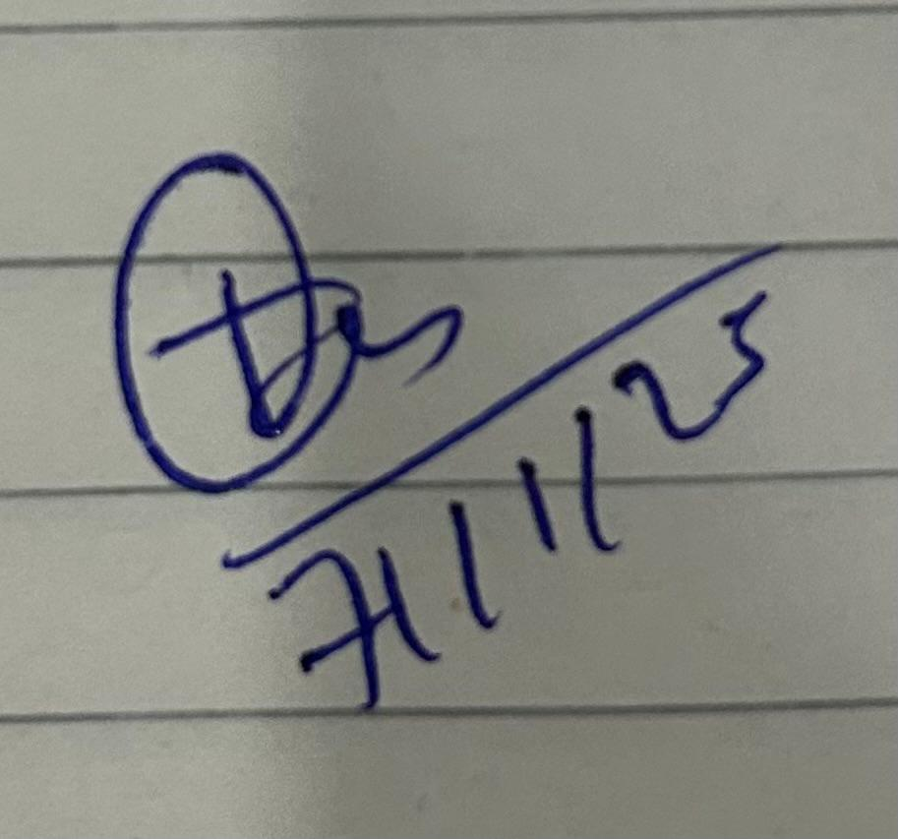
Trupal Sunil Tagade
Name and Signature of Student and Date
(Signature and Date in Handwritten)

Session | 2025-26 (ODD) |  | Course Name | Java Lab
Semester | 5 |  | Course Code | 23CT1506
Roll No | 77 |  | Name of Student | Trupal Tagade
Practical Number |  | 2
Course Outcome |  | Students will be able to apply the concepts of inheritance, polymorphism, and abstraction in object-oriented programming to design flexible and reusable systems that handle multiple object types and behaviors dynamically.
Problem Definition |  | Problem Def. 1:  Design a system to manage different types of vehicles. All vehicles have some common properties but different types of vehicles have their own specific features.  Class Vehicle with attributes brand and model and method displayInfo()  Derived class car with additional attribute numberofDoors, override method displayInfo() to include additional attribute.  Derived class MotorCycle with additional attribute hasCarrier. override method displayInfo() to include additional attribute.  Display information of all types of vehicles  Problem Def. 2:  Design a system that sends different types of notifications (Email, SMS, Push). Each notification type has its own way of formatting and sending messages. The system should be able to handle all types uniformly while allowing each to define its specific behavior.  Abstract class Notification with abstract method send(String to, String msg) and normal method getType() (Returns type of notification, eg. email, msg etc)  Derived class: EmailNotification, SMSNotification, PushNotification simulate the diff type of notifications with send(String to, String msg)  implement the class NotificationService with method notifyUser(Notification notification, String to, String msg). Accepts any notification type and calls send method
Theory  (100 words) |  | 1. Inheritance:  Definition:  Inheritance is one of the fundamental principles of Object-Oriented Programming. It allows a new class (child/subclass) to acquire the properties and behaviors (fields and methods) of an existing class (parent/superclass).  It helps in code reusability, extensibility, and hierarchical classification of objects.  Explanation:  The parent class contains common data and methods that can be used by all its child classes. The derived (child) classes can use, extend, or override these methods as needed.  Java supports single inheritance, meaning a class can inherit from only one superclass, but that superclass can have multiple subclasses.  Example:  class Vehicle {  void start() {  System.out.println("Vehicle starts");  }  }  class Car extends Vehicle {  void openDoors() {  System.out.println("Car doors opened");  }  }  Here, the Car class inherits the start() method from Vehicle.  This means Car objects can use both start() and openDoors() methods.  Key Advantages:  - Promotes code reuse.  - Supports hierarchical classification.  - Simplifies maintenance and updates.  2. Method Overloading:  Definition:  Method Overloading occurs when multiple methods in the same class share the same name but differ in parameters (number, type, or order).  It is a form of compile-time polymorphism (also known as static polymorphism) because the method call is resolved at compile time.  Explanation:  Overloading increases the readability and flexibility of code by allowing the same operation name to handle different types of input.  Example:  class MathOperations {  int add(int a, int b) {  return a + b;  }  double add(double a, double b) {  return a + b;  }  }  Here, both methods are named add(), but one accepts integers and the other accepts doubles.  The compiler decides which method to call based on the argument types.  Key Points:  - Happens within the same class.  - Determined at compile-time.  - Methods must differ by parameter list, not by return type alone.  3. Polymorphism:  Definition:  Polymorphism means “many forms”. It allows one interface (method name) to represent different behaviors depending on the object that is invoking it.  It is a key feature that allows for flexible and dynamic programming.  Types of Polymorphism:  - Compile-Time Polymorphism: Achieved through method overloading.  - Run-Time Polymorphism: Achieved through method overriding.  Explanation (Run-time):  When a subclass provides its own implementation of a method already defined in its superclass, it is called method overriding.  During execution, the JVM determines which method to call based on the actual object type — not the reference type.  Example:  class Vehicle {  void start() {  System.out.println("Vehicle starts");  }  }  class Car extends Vehicle {  @Override  void start() {  System.out.println("Car starts with key ignition");  }  }  public class Demo {  public static void main(String[] args) {  Vehicle v = new Car(); // Upcasting  v.start(); // Calls Car's start() -> Run-time polymorphism  }  }  Here, the reference v is of type Vehicle, but since it refers to a Car object, the overridden start() method of Car is executed at runtime.  Key Benefits:  - Promotes code flexibility and scalability.  - Allows the same interface to be used for different underlying forms (objects).  - Enables dynamic method invocation.
Procedure and Execution  (100 Words) |  | Algorithm:  P 1:  - Start the program.  - Create a base class named Transport with data members:  - manufacturer (brand name)  - series (model name)  and method displayDetails() to print these attributes.  - Create a derived class AutoCar that inherits from Transport.  - Add a new data member doors.  - Create method captureInfo() to read input from the user.  - Override the displayDetails() method to include number of doors.  - Create another derived class TwoWheeler that inherits from Transport.  - Add a data member hasCarrier.  - Create method captureInfo() to take input from the user.  - Override the displayDetails() method to include carrier information.  - In the main() method:  - Create objects of both AutoCar and TwoWheeler.  - Call their captureInfo() methods to read data.  Display all information using the displayDetails() method.  - End the program.  P2:  - Start the program.  - Create an abstract class Alert with:  - Data member category.  - Method getCategory() returning the type of notification.  - Abstract method deliver(String receiver, String message) to be defined in subclasses.  - Create subclasses:  - EmailAlert → defines deliver() to simulate sending email.  - TextAlert → defines deliver() to simulate sending SMS.  - PushAlert → defines deliver() to simulate sending push notification.  - Create a class AlertDispatcher with method sendNotification(Alert alert, String receiver, String message) that calls the deliver() method of any alert type.  - In the main() method:  - Display menu for user to select notification type.  - Accept receiver name and message from user.  - Create an object of the selected alert type.  - Pass the object to sendNotification() method to send the message.  - End the program.
Code 1 :
import java.util.Scanner;

class Vehicle {
String brand;
String model;

void displayInfo() {
System.out.println("Brand: " + brand);
System.out.println("Model: " + model);
}
}

class Car extends Vehicle {
int numberOfDoors;

void readData(Scanner sc) {
System.out.print("Enter Car Brand: ");
brand = sc.nextLine();
System.out.print("Enter Car Model: ");
model = sc.nextLine();
System.out.print("Enter Number of Doors: ");
numberOfDoors = sc.nextInt();
sc.nextLine();
}

void displayInfo() {
System.out.println("Brand: " + brand);
System.out.println("Model: " + model);
System.out.println("Number of doors: " + numberOfDoors);
}
}

class MotorCycle extends Vehicle {
String carrier;

void readData(Scanner sc) {
System.out.print("Enter MotorCycle Brand: ");
brand = sc.nextLine();
System.out.print("Enter MotorCycle Model: ");
model = sc.nextLine();
System.out.print("Does it have a Carrier? (Yes/No): ");
carrier = sc.nextLine();
}

void displayInfo() {
System.out.println("Brand: " + brand);
System.out.println("Model: " + model);
System.out.println("Has Carrier: " + carrier);
}
}

public class Main {
public static void main(String[] args) {
Scanner sc = new Scanner(System.in);

Car c = new Car();
MotorCycle m = new MotorCycle();

System.out.println("Enter Car Details:");
c.readData(sc);

System.out.println("\nEnter MotorCycle Details:");
m.readData(sc);

System.out.println("\n--- Vehicle Information ---");
System.out.println("\nCar Info:");
c.displayInfo();

System.out.println("\nMotorCycle Info:");
m.displayInfo();
}
}

Code 2:
import java.util.Scanner;

abstract class Notification {
String type;

String getType() {
return type;
}

abstract void send(String to, String msg);
}

class EmailNotification extends Notification {
void send(String to, String msg) {
type = "Email";
System.out.println("Sending EMAIL to " + to);
System.out.println("Message: " + msg);
}
}

class SMSNotification extends Notification {
void send(String to, String msg) {
type = "SMS";
System.out.println("Sending SMS to " + to);
System.out.println("Message: " + msg);
}
}

class PushNotification extends Notification {
void send(String to, String msg) {
type = "Push";
System.out.println("Sending PUSH notification to " + to);
System.out.println("Message: " + msg);
}
}

class NotificationService {
void notifyUser(Notification n, String to, String msg) {
System.out.println("\nUsing " + n.getType() + " Notification:");
n.send(to, msg);
}
}

public class Main {
public static void main(String[] args) {
Scanner sc = new Scanner(System.in);
NotificationService service = new NotificationService();

System.out.println("""
Choose Notification Type:
1. Email
2. SMS
3. Push
""");

int choice = sc.nextInt();
sc.nextLine(); // consume newline

System.out.print("Enter Receiver: ");
String to = sc.nextLine();

System.out.print("Enter Message: ");
String msg = sc.nextLine();

Notification n = null;

if (choice == 1) {
n = new EmailNotification();
} else if (choice == 2) {
n = new SMSNotification();
} else if (choice == 3) {
n = new PushNotification();
} else {
System.out.println("Invalid choice!");
return;
}

service.notifyUser(n, to, msg);
}
}
Output:

Code 1/output1:

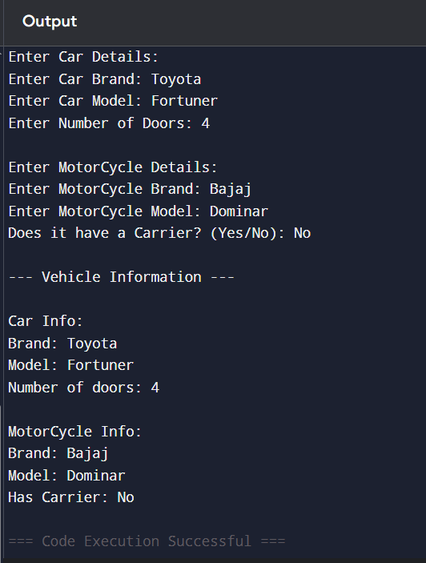

Code 2/Output2:

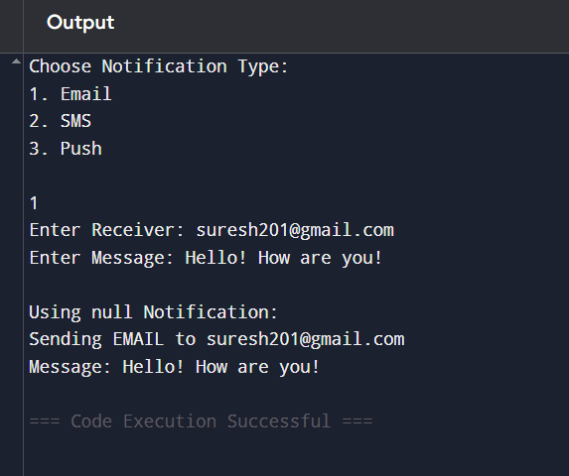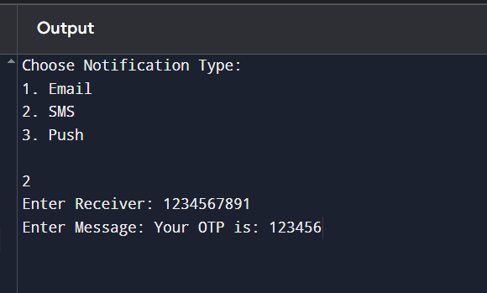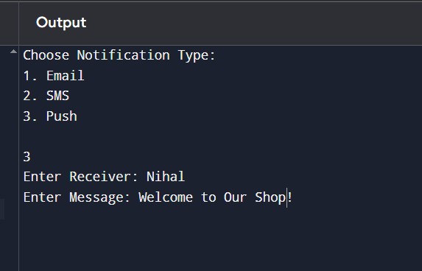

Output Analysis |  | P1:  - The system correctly reads inputs for both vehicle types.  - The displayDetails() method is overridden in each subclass, displaying additional attributes unique to that vehicle type.  - Demonstrates inheritance, overriding, and data encapsulation effectively.  - Output is clear, formatted, and matches the user’s input.  P2:  - The program dynamically decides which subclass to invoke based on user input.  - The deliver() method is implemented differently in each subclass, demonstrating run-time polymorphism.  - Output confirms that the message is sent via the selected notification type.  - The design is flexible — new notification types can be added easily without altering existing code.
Link of student Github profile where lab assignment has been uploaded |  | https://github.com/trupaltag2005/JFSD
Conclusion |  | P1:  The Vehicle Management System successfully demonstrates the concept of inheritance and method overriding in object-oriented programming.  By creating a common parent class and specialized child classes, the program efficiently manages shared and unique vehicle features, ensuring code reusability, clarity, and modularity.  P2:  The Notification System effectively applies abstraction and polymorphism to handle multiple types of notifications uniformly.Through the use of an abstract class and dynamic method implementation, the program achieves flexibility, scalability, and maintainability, making it easy to extend with new notification types in the future.
Plag Report (Similarity index < 12% |  | 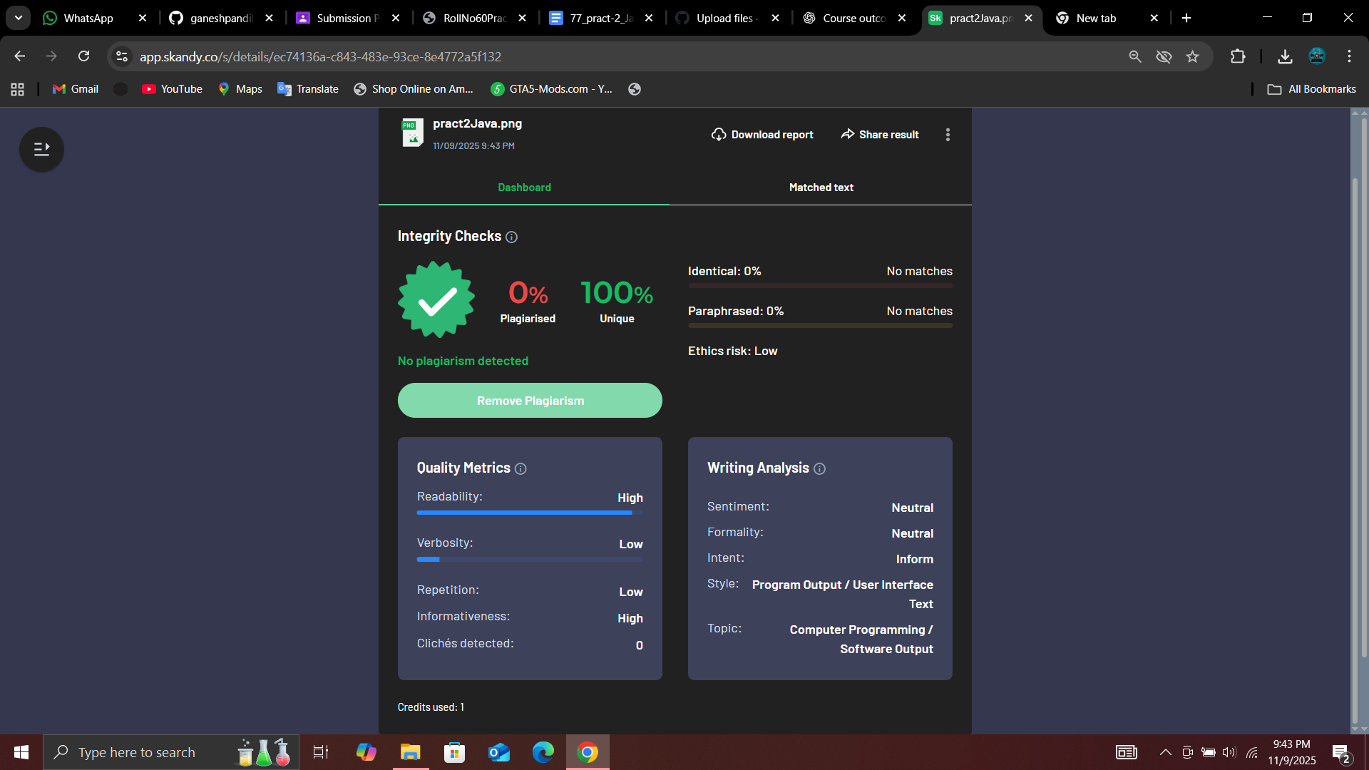
Date |  | 7/11/25

